**Introduction to Threads**

**What is a Thread?**

- Definition: A thread is the smallest unit of execution in a process. It allows for running different tasks within the same program.

**Process vs. Thread:**

- Process: An instance of a running program, isolated and independent.

- Thread: A sub-part of a process that shares memory and resources with other threads in the same process.

**Single-threaded vs. Multi-threaded Programs:**

- Single-threaded: Executes one task at a time (e.g., reading a file, processing it, then saving it).

- Multi-threaded: Multiple tasks are run simultaneously or concurrently, improving responsiveness.

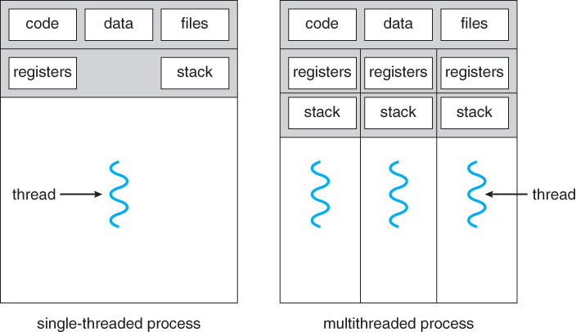

**Advantages of Threads:**

- Faster context switching compared to processes.

- Threads share the same memory, which makes communication between them easier.

- Better use of system resources, especially for tasks like file reading/writing or CPU-bound operations.

Example: Single-threaded Application in React

React is single-threaded, as JavaScript runs in a single thread. Here’s an example of a single-threaded operation in React:

```jsx

import React, { useState, useEffect } from 'react';

function SingleThreadedExample() {

const [data, setData] = useState(null);

useEffect(() => {

const fetchData = async () => {

// Simulate a single-threaded API call

const response = await fetch('https://jsonplaceholder.typicode.com/posts');

const result = await response.json();

setData(result);

};

fetchData();

}, []);

return (

<div>

<h1>Single Threaded Example</h1>

{data ? <pre>{JSON.stringify(data, null, 2)}</pre> : 'Loading...'}

</div>

);

}

export default SingleThreadedExample;

```

**State Management (useState):** We're using the useState hook to declare a piece of state, data, which is initially set to null.

**Fetching Data (useEffect):** The useEffect hook is used to run side effects in React. In this example, we simulate a single-threaded API call by fetching data from an external source (https://jsonplaceholder.typicode.com/posts) asynchronously using fetch.

**Asynchronous Operation:** The fetchData function is an async function, meaning it is non-blocking but still executes within the single-threaded event loop of JavaScript. Once the data is fetched and parsed, we update the data state using setData.

**Rendering the Data:** The data is displayed inside a <pre> tag to format the JSON for readability. While the data is being fetched, a "Loading..." message is shown.

**Introduction to Multithreading**

**What is Multithreading?**

- Definition: Multithreading allows multiple threads to run concurrently within a single process.

**Use Cases in React:**

- Concurrent Rendering (React 18): React can now render multiple components in parallel, optimizing the UI rendering process.

- Web Workers: JavaScript uses Web Workers to achieve multithreading-like behavior for CPU-intensive tasks.

Advantages of Multithreading:

- Better CPU utilization and responsiveness in I/O or CPU-bound tasks.

- Makes UI-based applications (like React apps) more responsive during background tasks.

Challenges of Multithreading:

- Race Conditions: Threads modifying shared data simultaneously can lead to incorrect results.

- Deadlock: Threads stuck waiting for each other to release resources.

Example: Using Web Workers in React

Web Workers allow background tasks to run without blocking the UI in React. Here's an example using Web Workers for a CPU-intensive task:

1. Create a Worker (`worker.js`):

```js

// worker.js

onmessage = function (e) {

let result = 0;

for (let i = 0; i < 1e9; i++) {

result += i;

}

postMessage(result);

};

```

2. Use the Web Worker in React:

```jsx

import React, { useEffect, useState } from 'react';

function MultiThreadedExample() {

const [result, setResult] = useState(null);.

useEffect(() => {

const worker = new Worker(new URL('./worker.js', import.meta.url));

worker.onmessage = (event) => {

setResult(event.data);

};

worker.postMessage('start');

return () => {

worker.terminate();

};

}, []);

return (

<div>

<h1>Multithreading with Web Workers</h1>

{result ? <p>Result: {result}</p> : 'Calculating...'}

</div>

);

}

export default MultiThreadedExample;

```

**Web Workers in React**:

* Web Workers allow React to offload CPU-intensive tasks (e.g., heavy computations) to a background thread. This keeps the main thread (UI) responsive while the background task runs.
* In this case, we’re simulating a task that adds up numbers in a loop, which can be computationally expensive.

**useEffect Hook**:

* **Purpose**: The effect is used to start the worker when the component mounts and terminate it when the component unmounts.
* **Creating the Worker**:
  + const worker = new Worker(new URL('./worker.js', import.meta.url)); dynamically imports the Web Worker (located at worker.js).
  + This is necessary because Web Workers run in a different thread and can’t access the DOM or the main thread's scope directly.
* **Message Handling**:
  + **worker.onmessage**: When the worker finishes its task, it sends a message back to the main thread with the result (via postMessage). This event handler receives the message and updates the state (setResult) with the calculated result.
* **Sending Data to the Worker**:
  + **worker.postMessage('start')**: Sends a message from the main thread to the worker to start the calculation. You can pass any data here if needed.
* **Cleanup**:
  + **worker.terminate()**: When the component unmounts, the worker is terminated to prevent memory leaks.

**Rendering**:

* The component initially displays "Calculating..." while the worker performs the task in the background.
* Once the worker completes, it updates the result and displays the calculated value.

**Advanced Multithreading Concepts**

Thread Synchronization

- Definition: Synchronization ensures that multiple threads don’t access shared data simultaneously in a way that causes conflicts.

In React, synchronization between asynchronous tasks can be managed with tools like `useEffect`, promises, and the `useReducer` hook to avoid race conditions.

Race Conditions Example:

In a React app, race conditions can happen when multiple asynchronous updates try to modify the same state. To avoid this, React ensures that state updates are batched.

Deadlock and Avoiding It

- In React, deadlocks can occur when there are competing state updates or effects waiting on each other, but this is usually managed by React’s concurrent rendering.

Thread Pooling with Web Workers

Thread pooling in web applications can be simulated using multiple web workers, distributing tasks across them.

Example: React with Multiple Workers:

```jsx

import React, { useState } from 'react';

function ThreadPoolingExample() {

const [results, setResults] = useState([]);

const startWorkers = () => {

const workers = [new Worker('worker.js'), new Worker('worker.js')];

workers.forEach((worker, index) => {

worker.onmessage = (event) => {

setResults((prev) => [...prev, `Worker ${index + 1}: ${event.data}`]);

};

worker.postMessage('start');

});

};

return (

<div>

<h1>Thread Pooling with Web Workers</h1>

<button onClick={startWorkers}>Start Workers</button>

<ul>

{results.map((result, i) => (

<li key={i}>{result}</li>

))}

</ul>

</div>

);

}

export default ThreadPoolingExample;

```

When you click the "Start Workers" button, two web workers are created. Each worker runs worker.js, where a heavy computation is simulated using a loop.

Both workers send their results back to the main thread, which are captured and displayed in the UI.

Since the workers run concurrently in separate threads, the heavy computation doesn't block the main UI thread.

**Challenges in Multithreading in React:**

- Synchronization: React uses its internal mechanisms to synchronize state updates.

- Race Conditions & Deadlocks: React provides hooks and patterns like `useEffect`, `useReducer`, and `useCallback` to avoid these issues.

https://www.techtarget.com/searchstorage/definition/race-condition#:~:text=A%20race%20condition%20is%20an,sequence%20to%20be%20done%20correctly.